**# Business Case for Star Car Rentals**

for implementing a new Cloud-based integrated System

**## The ISSUE**

Due to the lack of integration between the systems, the incorrect information has led to a loss of 25% market share accompanied by revenue reduction and customer dissatisfaction.

**## The problem statements**

Currently, the same data are input into multiple systems, we use batch files to manage these multiple data entries and update it at intervals to ensure the system can run up.

**## Analysis of the situation**

These measures of remediation are inefficient and error-prone. Once these errors occur, we have to sacrifice our revenue to fix them and what we got is extreme customer dissatisfaction. By July 2017 Sandra formed a task force to quickly scan and analyse all the data in the systems and have them all cleaned and reset. The operations were back to normal but this is due to the reduction in our sales and data volumes coming down. We should take this chance to implement a readily available cloud-based solution.

**## Solution options**

Adopting a centralized cloud-based administrative platform will increase the operation efficiency of the whole company and completely solve the information inconsistent problem. After completing an initial study of the requirements, ARS has provided the following quotation to Star Car Rentals.

Another option is to optimize and upgrade our current system. However, this is not a better option. Because cloud computing the modern trend. and it has many modern characteristics such as flexibility, disaster recovery, work from anywhere and Capital-expenditure Free etc.

**## Cost-benefit analysis**

In ARS quotation, the one-time cost for setting up the system is $510,000 and the recurring cost is $35,000 per month.

The estimated benefit could be $650,000 per year by eliminating lost sales and improving operating efficiencies.

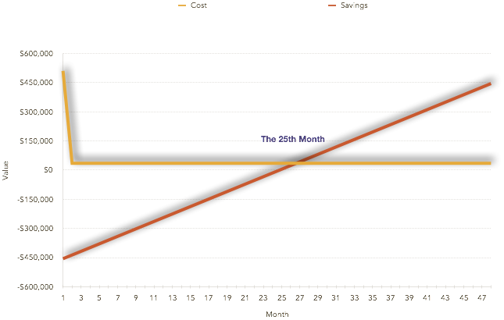

As the diagram shows, by the 25th month, the saved money will cover the total cost including the monthly cost. and leave us around $19,000 per month.

**## Recommendations**

The project can be divided into four phases:

- Requirements Analysis

- Configuration and Testing

- User Acceptance Testing

- Implementation including user training

The following three characters need to accomplish the project together.

- Project Manager

- Business Analyst

- Testers

The total estimated elapsed time would be 25months. Indeed, it is long term strategic of our company, it is critical to us future, we must put enough resources and attention to it.